

ML Lab assignement - 1

Perceptron – AND, OR and Sample Dataset



**NAME :** S. S. V. ADITYA NITTALA

**roll no: 177163**

**Salient Features:**

* As given in the pdf forwarded by the PhD scholars, the following algorithm was implemented:

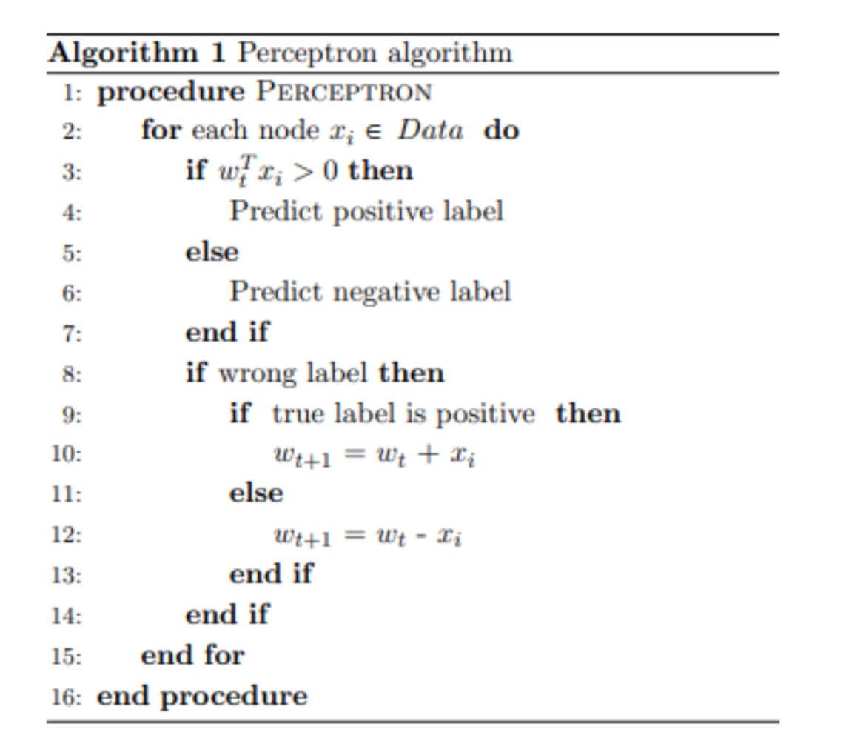

* The ***threshold*** function is also same as given in the pdf forwarded.
* The sample dataset is normalized using the z-score normalization.
* Data is split into 90% training and 10% testing.
* For the logic gates, the outputs printed are the bias and the weights.
* For the sample data, the test accuracy is printed.
* Code is attached below.